RDBMS:

What is RDBMS?

RDBMS stands for **R**elational **D**atabase **M**anagement **S**ystem. RDBMS is the basis for SQL, and for all modern database systems like MS SQL Server, IBM DB2, Oracle, MySQL, and Microsoft Access.

A Relational database management system (RDBMS) is a database management system (DBMS) that is based on the relational model as introduced by E. F. Codd.

**Rdbms** was developed by a jermen scientice mr. E.F codd at 1970 this model was developed on the basis of a mathematical concept called relational algebra.

Relations are classified into three types, they are;

* 1:1
* 1:M or M:1
* M:M (many to many)
* **one-one Relationship**
* In this relationship one object have only one relation with another object.
* one-one relationship
* In above image one employee have only one emp_id. this is the example of 1:1 relationship
* **one-many or many-one Relationship**
* In this relationship one object have relation with many other object.
* 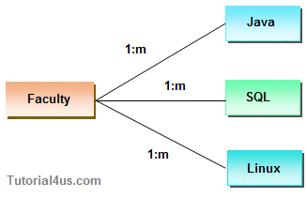
* In above image one faculty can teach many subjects. This is the example of 1:m relationship
* **many-many Relationship**
* In this relationship many object has the relationship with many other object.
* 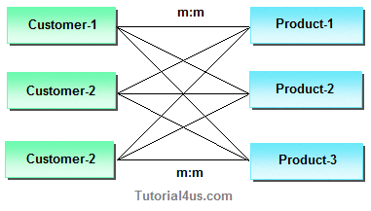
* In above image one customer can purchase many items and one item can purchase by many customers, this is the example of m:m relationship